Name : Sakthi Manoj R Reg No : 192324236
PROGRAM 7
Basic R Tasks: Factors, Random Integers, and FizzBuzz
Aim:
To write R programs for finding factors of a number, generating 10 random integers between -50 and 50, and printing numbers from 1–100 using FizzBuzz logic.
Procedure:
Step 1: Open RStudio or R console on your system.
Step 2: Assign an integer value to a variable to represent the number for which factors are to be found.
Step 3: Initialize an empty integer vector to store the factors.
Step 4: Use a for loop to iterate through all numbers from 1 to the given number.
Step 5: Inside the loop, use the modulus operator to check if the number divides evenly.
Step 6: If the condition is true, append that value to the factors vector.
Step 7: After the loop completes, print all the factors of the given number.
Step 8: Set a random seed to ensure reproducible random number generation.
Step 9: Generate and print 10 random integers within the range -50 to 50.
Step 10: Use another for loop to iterate from 1 to 100 and apply FizzBuzz logic.
Step 11: Print FizzBuzz for numbers divisible by both 3 and 5, Fizz for numbers divisible only by 3, Buzz for numbers divisible only by 5, and otherwise print the number.
Step 12: Display the complete sequence of outputs to verify the logic.
Output:
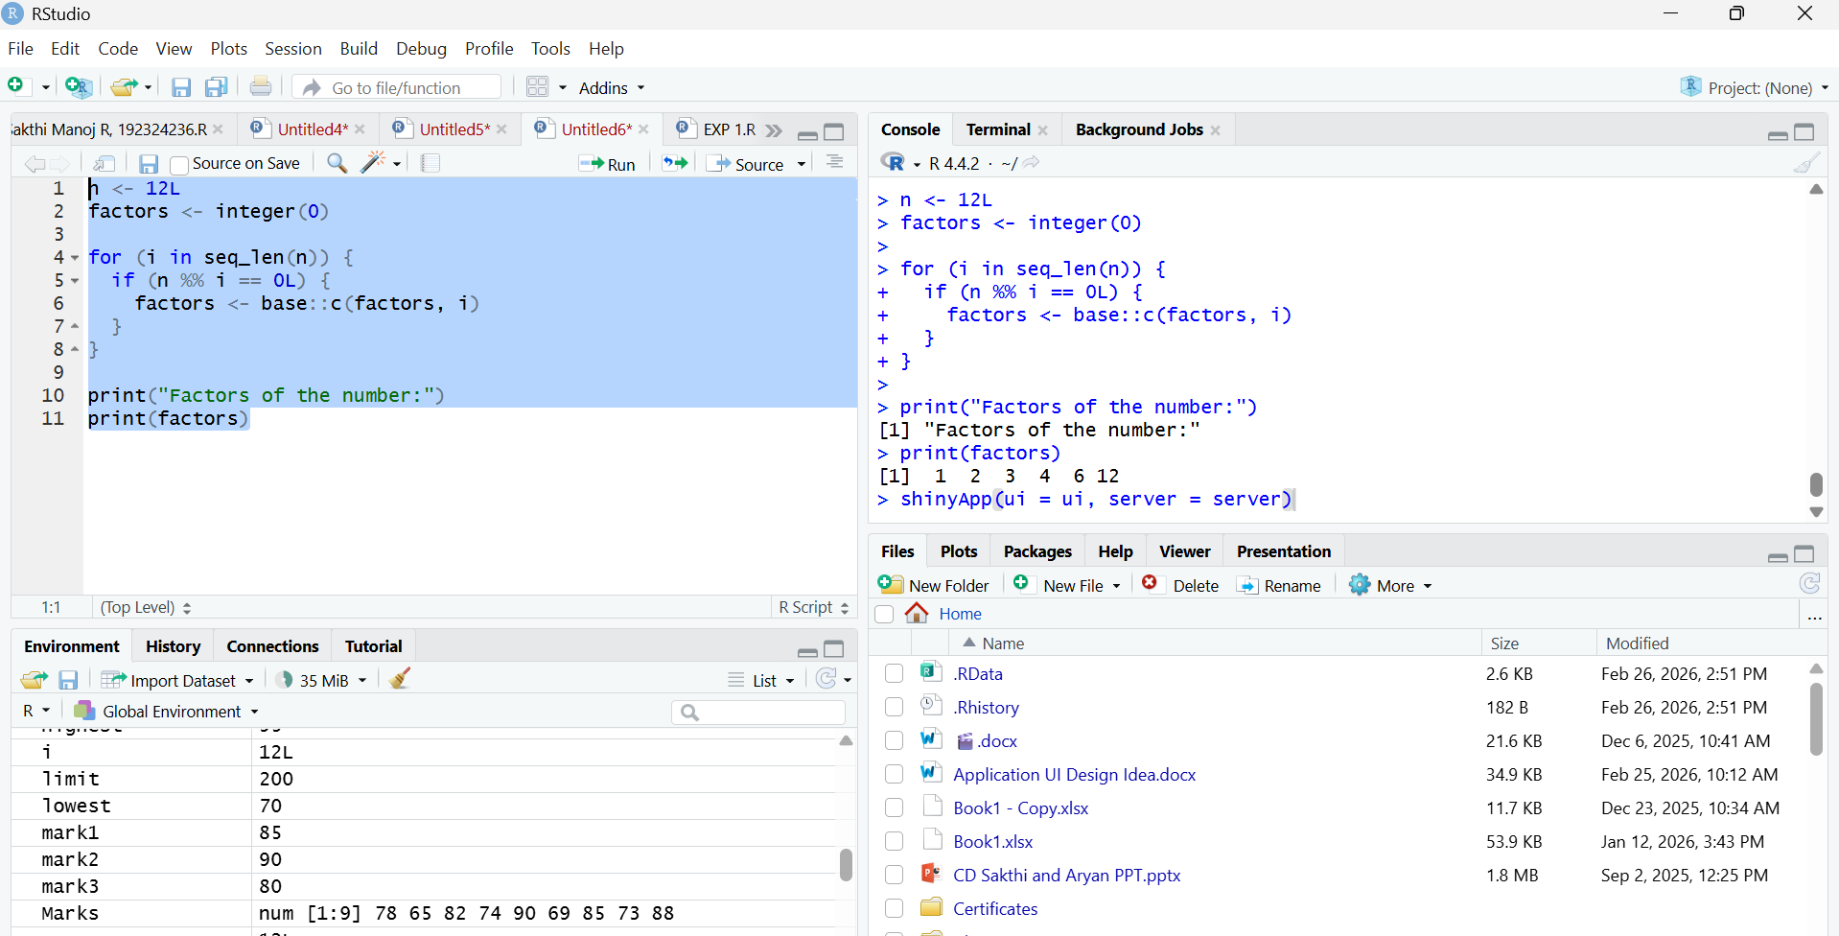
Result:
Hence the output is verified successfully.

